Lesson 10 Problem Set
G2.OA.4 Use Math Drawings to Partition a Rectangle

Name Date
- Shade in an array with 2 rows of 3.
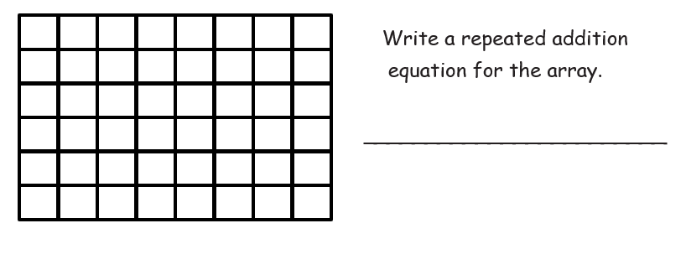
- Shade in an array with 4 rows of 3.
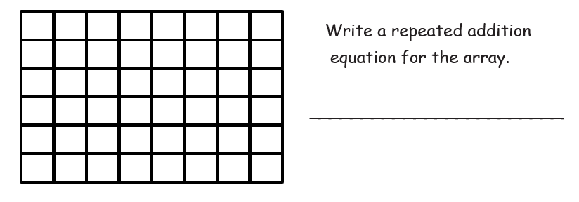

- Shade in an array with 5 columns of 4.
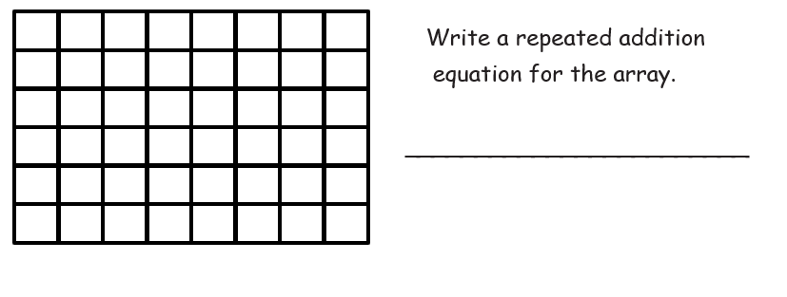

- Draw one more column of 2 to make a new array.
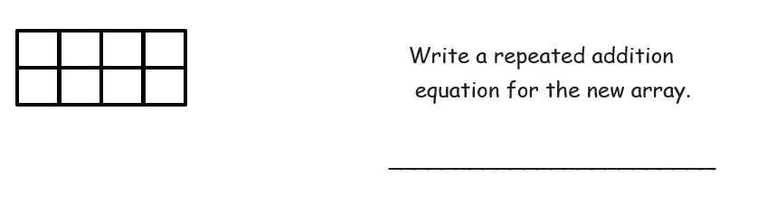

- Draw one more row of 4, and then one more column to make a new array.
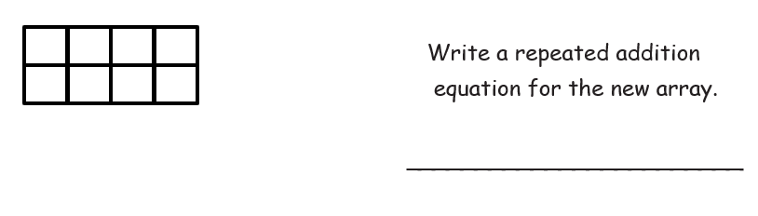

- Draw one more row and then two more columns to make a new array.

